**EDIT AND VIEW SHARED DOCUMENT ON OWNCLOUD AND VIEW ACTIVITY LOG FOR THE SAME USING AN OWNCLOUD APP**

1. **ABSTRACT**

Working on a shared document is simple and convenient for every user. An application similar to Google Docs created on ownCloud in which user can work on a shared document. User can view the latest edited data along with with the username, time and date of the last edit. Activity log of this file can also be viewed.

1. **INTRODUCTION:**

Document and file collaboration are the tools or systems set up to help multiple people work together on a single document or file to achieve a single final version. Normally, this is [software](https://en.wikipedia.org/wiki/Software) that allows teams to work on a single document, such as a [Word document](https://en.wikipedia.org/wiki/Word_document), at the same time from different [computer terminals](https://en.wikipedia.org/wiki/Computer_terminal) or [mobile devices](https://en.wikipedia.org/wiki/Mobile_device). Hence, document or file collaboration today is a system allowing people to collaborate across different locations using an [Internet](https://en.wikipedia.org/wiki/Internet), or "[cloud](https://en.wikipedia.org/wiki/Cloud_computing)", enabled approach

Document collaboration in a general sense simply refers to more than one person co-authoring a document. However, most people today when talking about document collaboration are referring to (generally internet based) ways for a team of workers to work together on an electronic document from computer terminals based anywhere in the world.

The documents on ownCloud can be edited and shared. It is similar to an application like dropbox and Google Docs. The user who logs into owncloud can open the app and start working on the shared document. The document can be viewed and edited by some other user. The changes will be reflected on the other users page after the file is reloaded. The details of last edited user is displayed along with the date and time of the last edit. Also the activity logs of the users who edited the document is saved and can be viewed.

1. **IMPLEMENTATION DETAILS:**

**Steps:**

1. Installation:

* To install Python 3 and pip:

sudo apt-get install python3 python3-pip

* Verify the Python version using:

python --version

* To install Python 3.2 and above:

sudo apt-get install python3-jinja2

* Install the ocdev tool:

sudo pip3 install ocdev

2) Setting development environment

ocdev setup <repositoryname>

ocdev setup -h

3) Starting php development server

php -S localhost:8080

4) Create an app

Go to:

cd /var/www/owncloud/apps

Next run:

ocdev startapp MyApp --email mail@example.com --author "Your Name" --description "My first app" --owncloud 8

Start app using:

ocdev startapp -h

**Code:**

<html>

<?php

$file = 'saved.txt';

// The new person to add to the file

$person = "John Smith\n";

$content = $_POST["content"];

$val=file_get_contents("saved.txt");

$val1=file_get_contents("act.txt");

// Write the contents to the file,

// using the FILE_APPEND flag to append the content to the end of the file

// and the LOCK_EX flag to prevent anyone else writing to the file at the same time

file_put_contents($file, $content);

$date = date("H:i, dS F, Y");

file_put_contents('act.txt', 'last edit was made by Student on:'.$date);

file_put_contents('activit.txt', '***************************last edit was made by Student on: '.$date."\n".PHP_EOL, FILE_APPEND | LOCK_EX);

// echo "$date";

// $content = $_POST["content"];

?>

<?php echo $val1; ?>

<form class="form-horizontal" action="try.php" method="post">

<div class="form-group">

<label class="col-md-4 control-label" for="content">Content</label>

<div class="col-md-4">

<textarea class="form-control" id="content" name="content" ROWS=20 COLS=50><?php

echo $val;

?></textarea>

</div>

<button class="btn btn-primary btn-lg" type="submit" value="Submit">

Submit</button>

</div>

</form>

<script>

function myFunction() {

location.reload();

}

</script>

<?php

echo "</br>";

echo file_get_contents("saved.txt");

echo "</br>";

?>

<button onclick="myFunction()">Reload page</button>

<form action="redirect.php">

<input type="submit" value="Show activity log">

</form>

**Redirect.php**

<?php

//echo "</br>";

$file = './activit.txt';

// Open the file to get existing content

$current = file_get_contents($file);

//echo "ji";

echo $current;

?>

1. **RESULTS:**

Shared document​ has been created. Last modified user details has been displayed. Name of the user, date and time are also a part of the logs.

1. **SNAPSHOT:**

First page

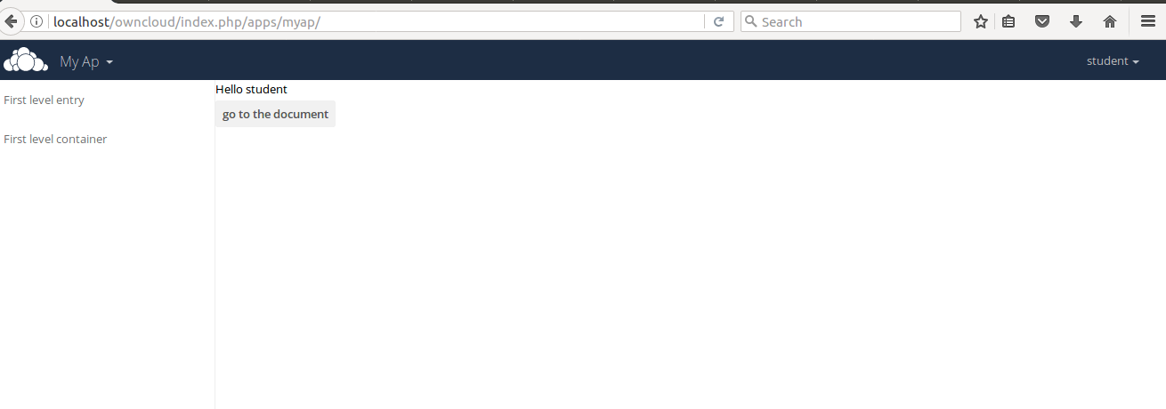

Before editing

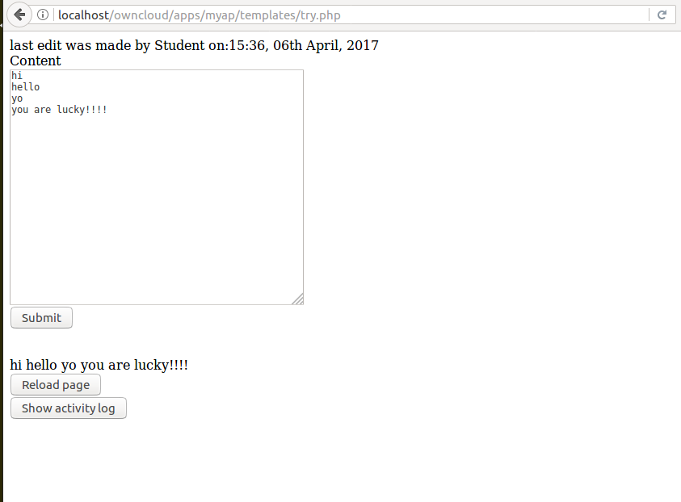

After editing

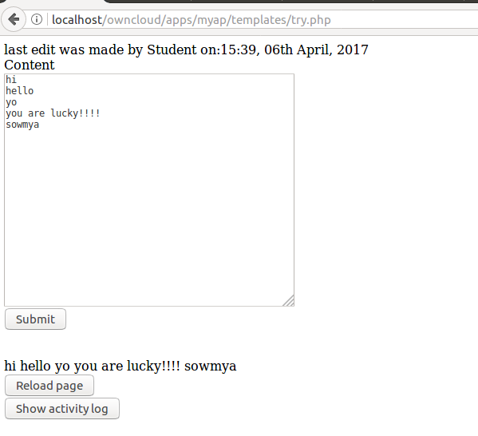

Changes in the doc are saved

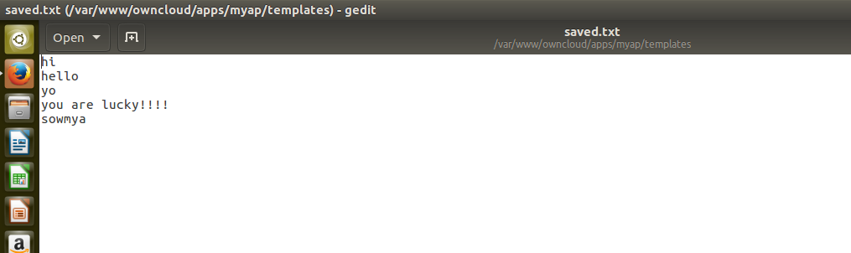

Displaying activity log file

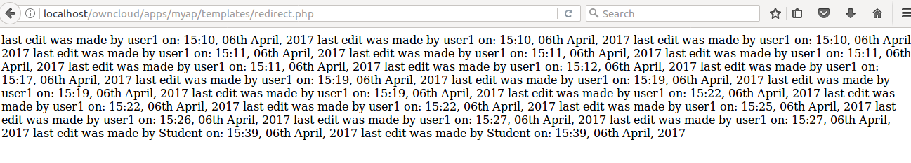

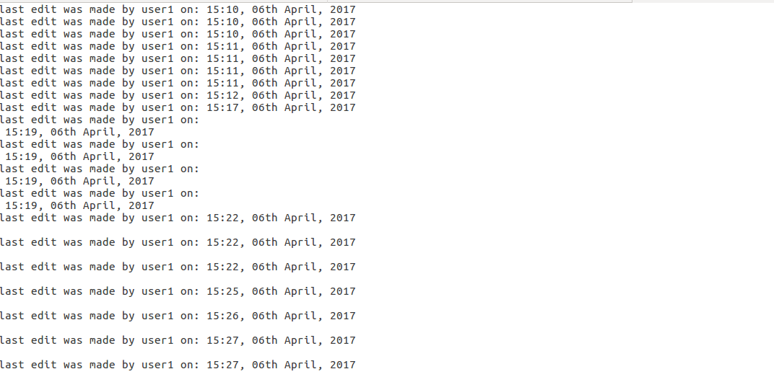

Last edit saved in another file

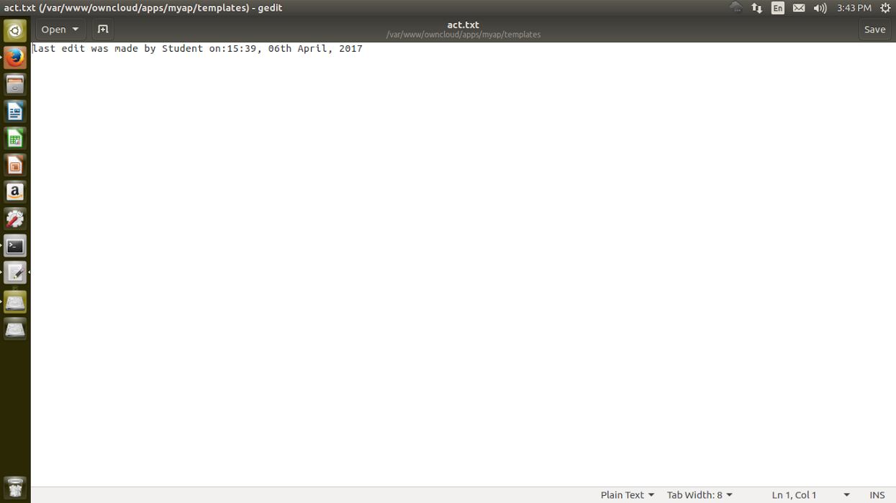

1. **CONCLUSION:**

Hence a log of activities performed by a particular user can be viewed. Also the edit made by the user will be saved until further edited. The logs include the user name and the date and time of edit.

1. **REFERENCES:**

[1]<https://apps.owncloud.com/content/show.php/ActivityLog?content=174809>

[2]<https://apps.owncloud.com/content/show.php/Storage+Usage+%2B+Activity+Charts?content=166746>

[3]<https://forum.owncloud.org/viewtopic.php?t=18617>

[4]<https://apps.owncloud.com/content/show.php/Storage+Usage+%2B+Activity+Charts?content=166746>